Python basics
Question 1: What is Python and why is it widely used in Data Analytics? Mention any three reasons.

Answer:
Python is a high-level, interpreted programming language that makes it easy for anyone — to learn and use. It’s known for its simple syntax, readability, and versatility — meaning it can be used for almost anything: from building websites to analyzing data or training AI models.
Python is often described as a “beginner-friendly language”, but it’s also powerful enough to be used by professionals and large tech companies.

- Beginner Friendly as Python has simple, readable syntax. Also it is a good start for non-programmers.
- Easy Syntax as Python uses natural language structure where indentation makes the code readable.
- Python has Large Community Support.
- Powerful Libraries like Pandas, NumPy, Seaborn, Matplotlib, Scikit-learn

Question 2: Explain the difference between List and Tuple in Python.

Answer:
List
A list is an ordered collection of items, where each item can be of any data type (e.g., integers, strings).
Lists are written using square brackets [].

Key Features:
- Mutable: Items can be added, removed, or changed.
- Indexed: Items can be accessed using their position in the list.

Tuple
- Definition: A tuple is an immutable sequence of items, meaning the elements cannot be changed after the tuple is created.
Tuples are written using ().

- Key Features:
  - Ordered: Elements maintain their sequence.
  - Immutable: No addition, removal, or modification of items.
  - Allows Duplicates: Like lists, tuples can have duplicate values.

Why Use Tuples?
- Use tuples when you need a fixed collection of items that won’t change.
- Suitable for data that must remain constant, such as coordinates, configuration settings, or dictionary keys.

Question 3: What is a function in Python? Why are functions useful?

Answer:
A function is a block of reusable code that performs a specific task.
Instead of writing the same code repeatedly, we can create a function once and call it whenever needed.

Advantages
- Code Reusability
- Reduces repetition
- Makes code easier to understand
- Easy to debug and maintain
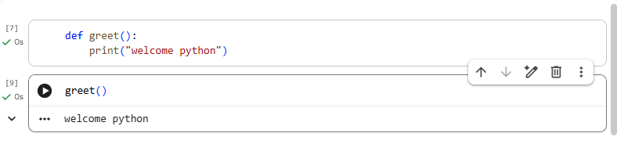

Question 4: Write a Python program to take a user's name as input and print a greeting message.
Answer:
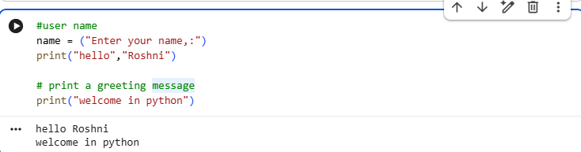

Question 5: Write a Python program to check whether a number is even or odd using conditional statements.

Answer:

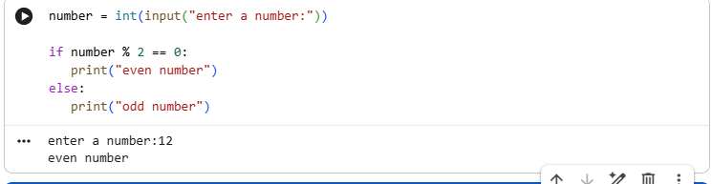
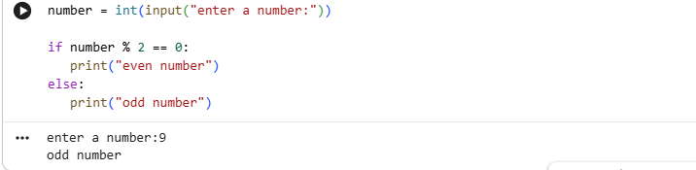

Question 6: Write a program to print numbers from 1 to 10 using a loop.

Answer:
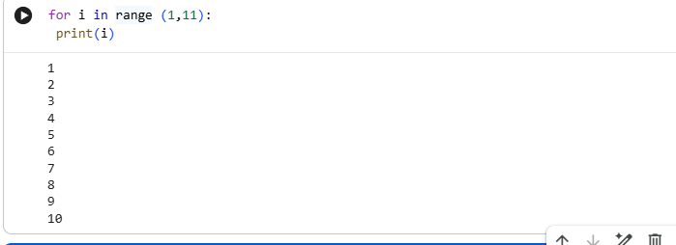

Question 7: Create a list of five numbers and print the maximum number from the list.

Answer:
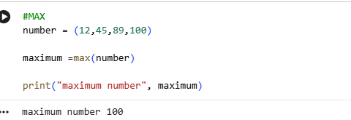

Question 8: Write a Python program to remove duplicate values from a list using a set.

Answer:
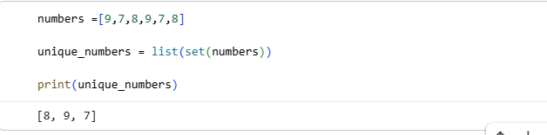

Question 9: Write a function that returns the square of a number.

Answer:
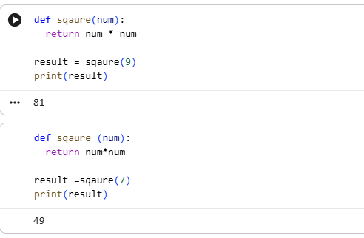

Question 10: Write a Python program to count how many times a number appears in a list. Example List.
[2,3,4,2,5,2].

Answer:
